Design, Development, and Implementation OF A Competitive Workout Tracker Cross Platform Application

A Senior Project Submitted to the
Department of Computer Systems Engineering Technology
of the School of Engineering, Technology, and Management at the Oregon Institute of Technology
in partial fulfillment of the requirements for the Degree of
Bachelor of Science

Riggs Burnham

abstract

Gods Among Sheep is a cross-platform mobile application (Android and iOS) written in C# using Xamarin.Forms, where the data is stored in a MariaDB hosted on AWS. The objective of GAS is to promote fitness through a healthy competitive environment. GAS allows users to log and track their workouts, friend other users, and view their past workouts and create workout groups to compete and communicate with other users in the workout groups. Workout groups track each workout a user adds after they have joined the workout group.

List of Acronyms

GAS Gods Among Sheep
API Application Programming Interface
ERD Entity Relationship Diagram
UML Unified Modeling Language
MariaDB Relational Database based off MySql
AWS Amazon Web Services
CRUD Create, Read, Update, Delete
Summary Table of Contents

Chapter 1 Introduction 6
Chapter 2 Background 7
Chapter 3 Functional Description 9
Chapter 4 Detailed Description 14
Chapter 5 Test Results & Validation 19
Chapter 6 Summary 27

Table of Contents

Chapter 1 Introduction 6
Overview 6
Product Description 6
Problem Statement 6
Summary 6
Report Outline 6
Chapter 2 Background 7
Overview 7
Background Information 7
State of the Art 8
Summary 8
Chapter 3 Functional Description 9
Overview 9
Functional Description 9-12
Architecture 13
Summary 13
Chapter 4 Detailed Description 14
Overview 14
Detailed Description 14-17
Summary 18
Chapter 5 Test Results & Validation 19
Overview 19
Test Plan 19-22
Test Results 23-25
Discussion 26
Summary 26
Chapter 6 Summary 27
Overview 27
Project Summary 27
Future Direction 27
Concluding Remarks 28

Introduction

Overview

Chapter 1 will provide a detailed description of the Gods Among Sheep application, it will also provide a problem statement and how GAS intends to solve that problem.

Product Description

Gods Among Sheep is a cross platform application (Android and iOS) that provides a competitive environment that motivates people to work out. The objective of GAS is to promote fitness through a healthy competitive environment. GAS allows users to log and track their workouts, friend other users, and view their past workouts and create workout groups to compete and communicate with other users in the workout groups. Workout groups track each workout a user adds after they have joined the workout group.

In order to use the application the user will need to provide their own mobile device (either Android or iOS) and will need internet access in order to communicate with the MariaDB hosted on AWS. Users will be required to create an account in order to use the application.

Problem Statement

There are many ways for people to track their workouts and there a few applications that allow people to do so, these applications however are cumbersome, difficult to use, and don’t provide a sense of friendly competition in order to motivate users to work out. I chose to develop this project in order to allow users to easily log and track their workouts, friend other users and view their workouts, allow users to join groups where they can compete against each other and communicate in order to promote fitness.

Summary

The goal of Gods Among Sheep is to allow people to easily log and track their workouts, and to provide a friendly competitive environment that will motivate people to workout and promote good fitness. With the goal of competition in mind it was crucial for this application to be cross platform so users can compete, regardless of the operating system their mobile device is running on.

Background

Overview

The purpose of this chapter is to provide a context for Gods Among Sheep. This chapter will include the background information that led to the idea of this project, and what applications are being used to achieve similar results.

Background Information
Many people workout and for the people who do it isn’t always easy motivating one-self to go out and run or go to the gym to exercise. There are many ways to increase motivation such as rewarding one-self for performing a task, be it material such as eating your favorite food or just the sense of accomplishment. One of the major factors that motivates people to do something they may not entirely want to do, would be through a sense of positive peer pressure or even healthy competition.

Competition was the main thing in mind when considering developing this application, the question I wanted to answer was “How can I motivate people to work out?”. Through my own experience I realized I work out the most when I know I’m not the only one trying to better myself and I have friends who are telling me to go to a gym and get fit. With this thought in mind I decided it would be cool for there to be a mobile application that will provide an environment for healthy competition for working out.

Gods Among Sheep hopes to achieve this by:
- Allowing users to log and track their past workouts.
- Allowing users to friend other users and view their past workouts.
- Allowing users to create workout groups and invite other users into the
workout group.
- Allowing users to view each competitors workout in workout groups and to have a group chat to augment the motivation to workout by providing a sense of competition.
- Award users trophies for meeting milestones, such as working out seven days in a row.
- In workout groups determine a winner each week by who worked out the most, crowning them that week’s champion.

State of the Art

There isn’t really any application out there that is trying to achieve what my goals for this project are, this is one of the reasons why I decided to do such a project. There are applications out there that are similar such as the Fitbit application.

Fitbit
The Fitbit mobile application utilizes a Fitbit to track information of the wearer, such as blood pressure, steps taken, distance traveled, and calories burned. The Fitbit application does provide cool ways to view your past activity but does not provide an environment for tracking specific workouts; the only things the Fitbit can capture is blood pressure, steps taken, distance traveled, and calories burned. Fitbit does allow the friending of other users but because it doesn’t track the specifics of a workout it doesn’t provide as competitive of an environment as it could if it were allowing users to say exactly what they were doing to travel that distance or to what they were doing to have a higher blood pressure.

Summary

It’s surprise to me to see that there isn’t an app out there that supplies the competitive environment and motivation to workout, when it’s something mostly everyone needs that extra motivation to go out and do. There are apps that help with this but don’t go as into depth that will help provide a friendly competitive environment to motivate people to workout. Providing friendly competition and the motivation to workout is the goal of Gods Among Sheep and is what allows GAS to stand out besides other similar applications.

Functional Description

Overview

This chapter will provide a detailed description of the layout of every page in the application and what their intended purpose is.

Functional Description

- Flyout Menu
The flyout menu provides the majority of the navigate for GAS, it can be accessed by either swiping to the right or clicking the hamburger in the top left corner of the application. The flyout menu provides navigation to the home page/workouts page, the login page, the logout page, the add workout page, the friends list page and the workout group page.

- Home Page/Workouts Page
The home page/workouts page is a page for viewing your past workouts. Workouts are displayed in descending order starting from the most recent workout. Each workout displays the total length of the workout and the date of the workout. Clicking on a workout navigates to the workout details page.

  - Workouts Details Page
The workout details page is a page for displaying a specific workouts information. The page shows all the information of the workout; It displays the total length of the workout, what exercises went into getting that total length, the description for the workout and the date of the workout.

- Login Page
The login page takes a username and a password in order to log in. If the user has not yet registered an account, the user can click the register button and navigate to the register page.

- Register Page
The register page is for creating new GAS users. The register page has a username field, a password field and a confirm password field. Usernames and passwords need to be between 3-256 characters long. Passwords need to include at least 1 number, 1 upper case character and 1 special character. Clicking the register button registers the user to the database, using a salted hash on the password for encryption and navigates back to the login page.

- Add Workout Page
The add workout page is for adding workouts to the user. The add workout page has a date time picker for selecting the date, switches indicating what exercise (exercises are: arms, legs, back, shoulders, abs, chest, cardio, sports) was done, an entry for description allowing the user to provide the exact workouts if the user wants to, and a list indicating all the exercises done in that workout with the time spent on that exercise and the total length of the entire workout. Clicking on the switches for an exercise causes the add exercise popup menu to popup.

  - Add Exercise Popup
The add exercise popup is for adding an exercise to a workout. All this popup menu has is a field for the length of that exercise. Clicking the add button adds that exercise to the workout.

- Friends List Page
The friends list page is a page for displaying all the friends the user has, if the user has no friends then is displays “Its lonely here, add a friend…”. The page has a button to search for users to add as a friend. Clicking the add friend button will cause the add friend popup to popup.

  - Add Friend Popup
The add friend popup is for searching for users to send a friend request to. The popup has an entry for searching for a user and a list that gets populated with the users found. As the user types into the search entry found users will automatically populate if they exist in the database after 3 characters have been typed, typing more characters will narrow down the list.

  - Friends Workouts Page
The friends workouts details page is for viewing your friends past workouts. Friends workouts are displayed in descending order starting from the most recent workout. Each workout displays the total length of the workout and the date of the workout. Clicking on a friends workout navigates to the friends workout details page.

    - Friends Workouts Details Page
The friends workout details page is a page for displaying a specific workouts information. The page shows all the information of the workout; It displays what user did the workout, the total length of the workout, what exercises went into getting that total length, the description for the workout and the date of the workout.

- Notifications Page
The notifications page is for displaying all notifications that can occur in the application, be it a workout group invitation or a friend request. The page has two lists and four buttons. One of the lists to display all friend requests followed by two buttons, one to accept the friend request and one to decline the friend request. The other list is to display all workout group requests followed by two buttons, one to accept the workout group request and another to decline the workout group request.

- Workout Groups Page
The workout groups page is a page for displaying all workout groups the user is a part of and for providing the ability to create, manage and the navigation to workout groups. This page has four buttons, one to create a workout group, one to delete a workout group, one to manage a workout group and one to navigate to that workout group. If a user tries to manage or delete a workout group that they are not the leader of they will be told they don’t have the right to perform that operation.

  - Create Workout Group Page
The create workout group page is for creating a workout group for users to compete in. This page has an entry for the workout groups name, a list that displays all the user’s friends with a switch next to their username indicating if they will be invited into the group or not. The page has one button to create the workout group, if pressed it will add the workout group to the database and send out the workout group requests to the selected users.

  - Manage Workout Group Page
The manage workout group page is to manage an existing workout group; only the leaders or creators of a workout group can manage a workout group. The manage workout group page contains a label indicating the name of the workout group being managed, a list of the all the competitors usernames, and four buttons; one to invite friend(s), one to kick a friend, one to promote a friend to the workout group leader, and one to delete the workout group entirely. Clicking the invite friend(s) button will cause the invite friends popup to appear. Clicking the kick friend button will remove the selected friend from the workout group. Clicking the promote leader button will promote the selected friend to the leader of the workout group and then will navigate back to the workout groups page. Clicking the delete workout group button will delete the workout group and then navigate back to the workout groups page.

    - Invite Friends Popup
The invite friends popup is to invite more friends into the workout group. The page contains a list of the users friends, a slider next to their name indicating if they want to be invited into the group or not and a button to invite the selected friends.

  - Workout Group Page
The workout group page is a page that shows the workouts of all the competitors past workouts. Competitors workouts are displayed in descending order starting from the most recent workout. Each workout displays the total length of the workout and the date of the workout. Clicking on a competitors workout navigates to the competitors workout details page. At the bottom of the page there is a button to navigate to this workout group’s group chat page.

    - Competitors Workout Details Page
The competitors workout details page is a page for displaying a specific workouts information. The page shows all the information of the workout; It displays what user did the workout, the total length of the workout, what exercises went into getting that total length, the description for the workout and the date of the workout.

    - Group Chat Page
The group chat page is for providing an area in which each competitor in a workout group and communicate with each other to motivate one another to workout through friend competition. The page contains a list that displays each message along with what user sent the message and at what time. The page also contains an entry to write messages and a button to send the message.

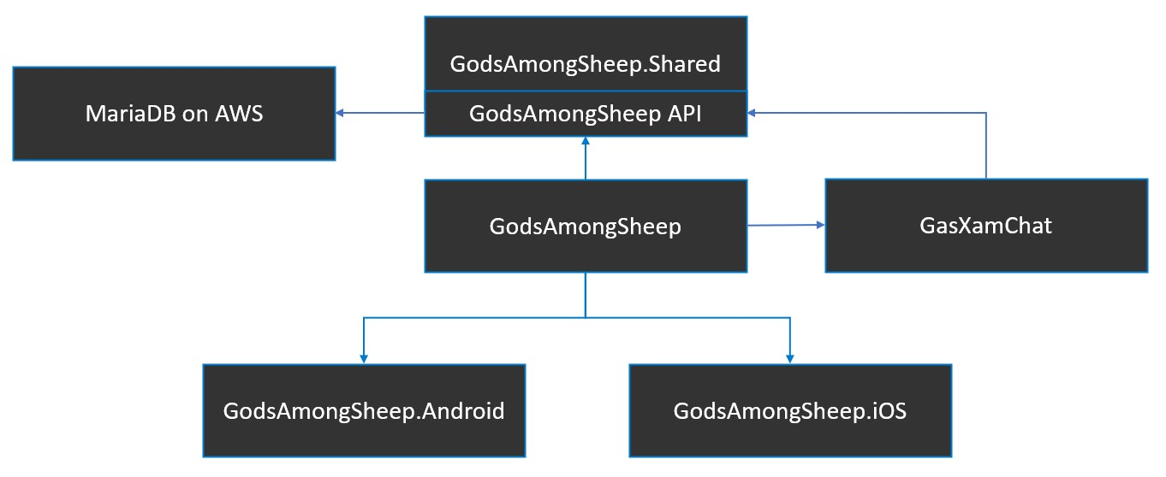
Architecture
Figure 1 – Project Layout

The block diagram in figure 1 provides the project layout of the application. Since this project is making use of Xamarin.Forms there is a shared UI across the application. The GodsAmongSheep project connects to a chat service and to an API that handles communication to the MariaDB hosted on AWS. On application startup the shared UI gets built from the GodsAmongSheep project and any custom renderers are then delegated to proper project be it GodsAmongSheep.Android or GodsAmongSheep.iOS. The GodsAmongSheep project communicates to the databases through an API that handles CRUD operations on the database. In group chats the GodsAmongSheep project communicate with the GasXamChat service which handles writing and reading messages to the API.

Summary

The flow of gods among sheep was designed to be intuitive, where each page is only managing a specific part of the application. In doing so this created many pages in the application but they are hooked together in a way so it will be easy to navigate to whatever part of the application the user wants to utilize.

Detailed Description

Overview

This chapters goal is to provide a detail description of the major components that make up this application. It will include diagrams for each major piece of the application, the front end, the API and the database.

Detailed Description

- Xamarin.Forms Mobile Application
The mobile application is written in C# using Xamarin.Forms in order to create a shared UI across the cross platform application for both Android and iOS.
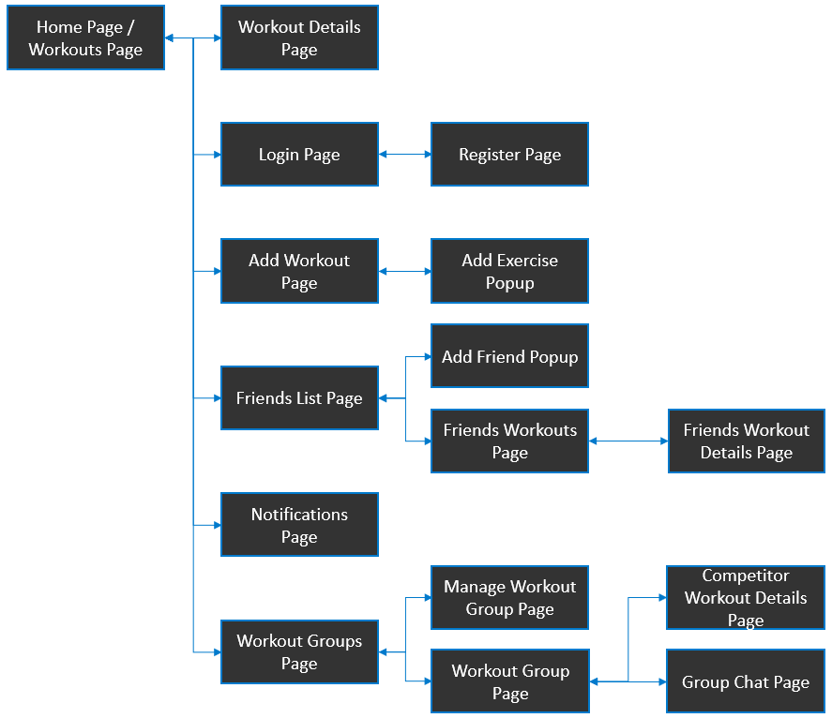

Figure 2 – Page Navigation Diagram
The diagram in figure 2 shows how you can navigate between the many pages of the application. There are quite a bit of pages in this application but it is designed to be intuitive where all nested pages have something to do with its parent page.

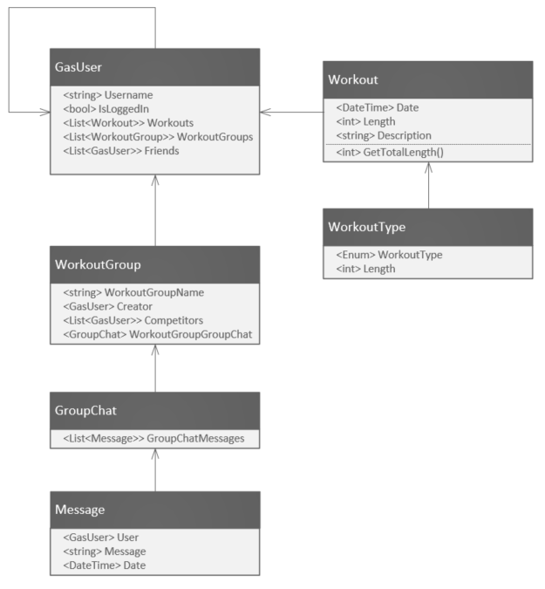
Figure 3 – UML Class Diagram
The diagram in figure 3 shows the class diagram of the application and how each individual class is related to each other.

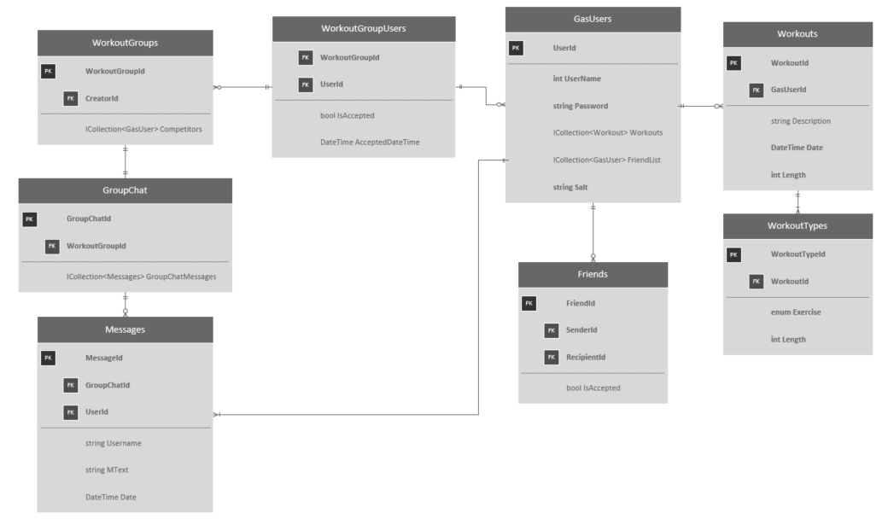
Figure 4 – ERD
Figure 4 is the entity relational diagram and shows how each individual object is related to each other in the MariaDB database hosted on AWS.

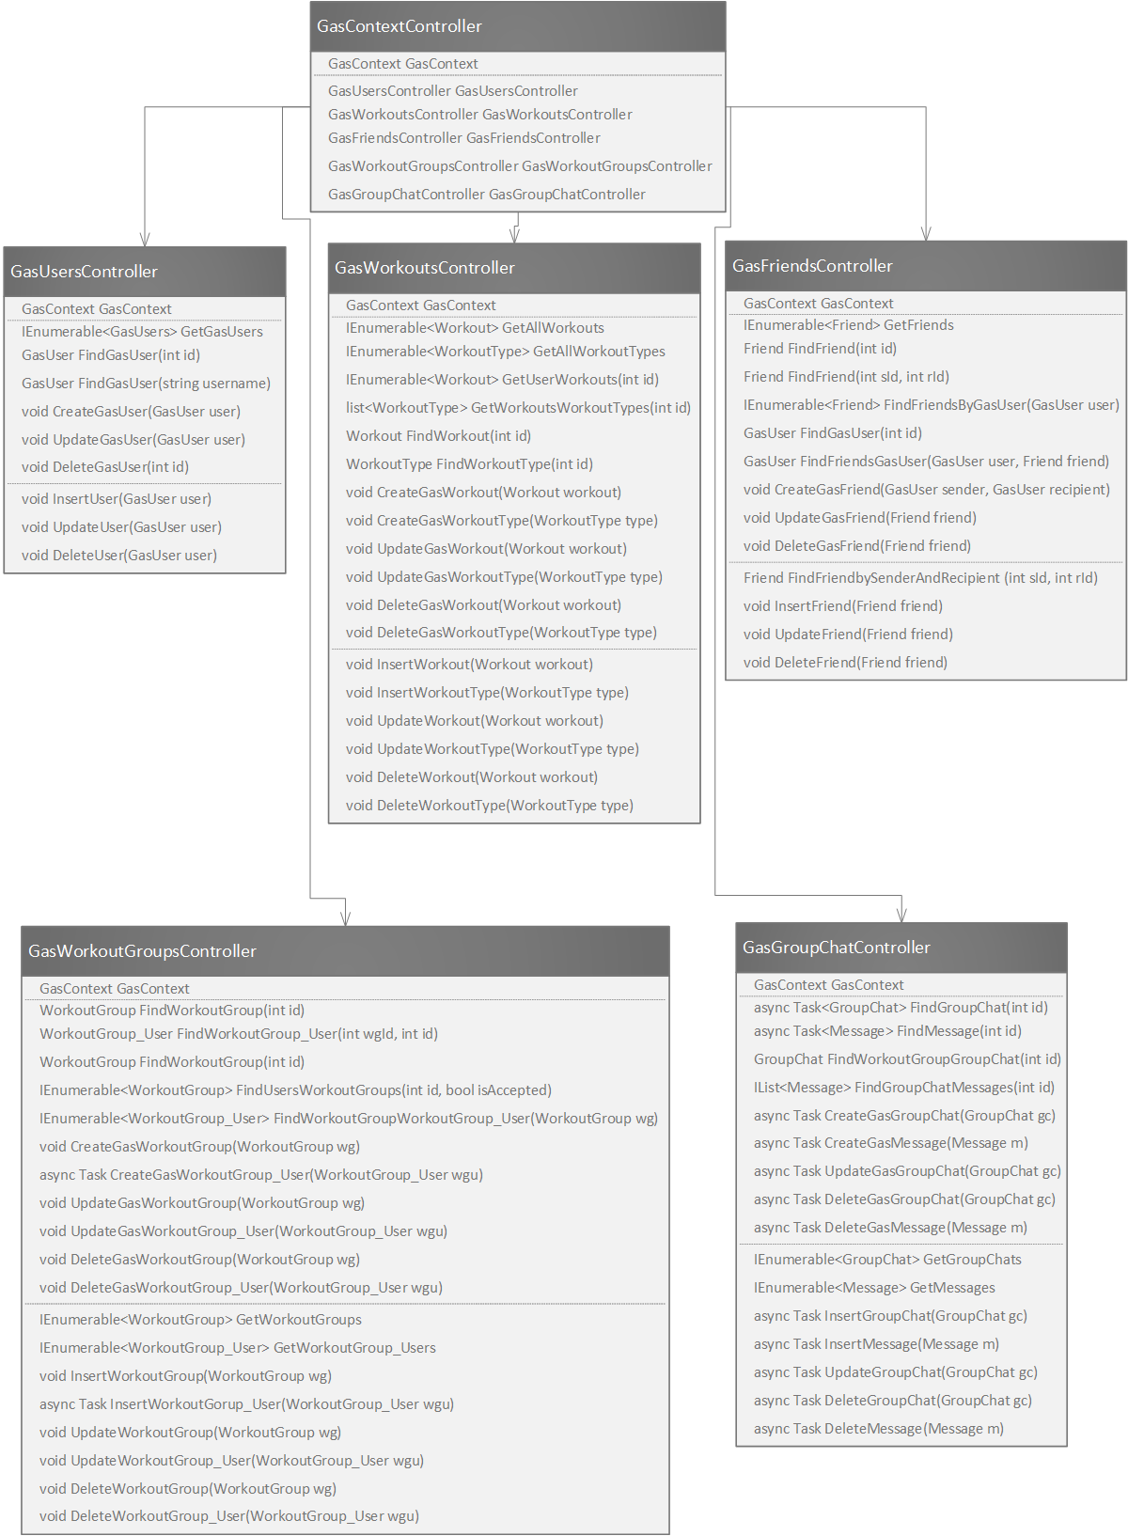
Figure 5 – API UML
The diagram in figure 4 is a representation of the API that is being used to access the MariaDB.

Summary
Each part of the architecture impacted the design, development, the flow, and the look of the application. The use of an API allows calls to be made safely to the database without corruption as the controls are specifically designed to interact with the database safely.

Test Results & Validation

Overview

This chapter will go over the method used to determine if Gods Among Sheep meets the functional requirements as specified in the proposal. Next that chapter will cover usability testing and its results and then will summarize the meaning of the results.

Test Plan

Functional Testing
To verify if Gods Among Sheep meets its expected behavior, a test plan was created that demonstrates the expected results of the end product. The test plan is outlined below.

- Creating an account
  - Use flyout to navigate to login page, click register button and be navigated to register page.
  - Enter username, password, and confirm password. Usernames must be unique, and passwords must have at least 1 uppercase character and 1 special character.
  - Provide error messages for bad input (non-unique usernames, non-matching passwords, passwords that are not strong).
  - Upon creating an account navigate back to login screen.
- Logging in
  - Use flyout to navigate to login page.
  - Enter credentials (username and password).
  - Click login button to login.
  - Provide error messages for bad input (either the password or username or both are incorrect).
  - Upon logging in navigate back to the home page.
- Adding a workout
  - Use flyout to navigate to the add workout page.
  - Use datetime selector to select the date of which the workout took place.
  - Use switchers to pick what type of workout(s) was done on that day (more than one can be selected).
  - When a switcher is clicked show a popup window to ask for the length of that specific exercise.
  - Use the entry form to provide a detailed description for the workout, allow it to be optional but it will allow users to record the specifics of a workout such as how many reps at what weight.
  - Show a list of all the workout types and the length of the exercises along with the total workout length.
  - Use add workout button to add the workout to the users list of workouts to be displayed on the home page.
  - Upon adding a workout navigate back to the home page.
- Viewing your workouts
  - The homepage will show all the workouts the user has recorded, from most recent workout to the first recorded workout.
  - Display the workout length and the date.
  - Clicking a workout will navigate to the workout details page.
- Viewing your workout details
  - Shows the date the workout was recorded, the description of the workout, the length of each exercise and the total length of the workout.
- Viewing Friends
  - Use the flyout to navigate to the friends page.
  - Shows a list of the users friends, if they have none give a message indicating that they currently have no friends and that they should add one.
  - Clicking the add friend button will show the add friend popup.
  - The add friend popup has an entry where the user can search for a friend by username.
  - Dynamically populate the list of friends found as the user is typing in the username to speed up the process for the user and to provide validation that they are finding the user they are looking for.
  - Clicking the add friend button when send a friend request, the two users however will not be friends until the recipient accepts the friend request.
- Viewing Friends Workouts
  - Clicking on a friends username on the friends page will navigate to all their workouts.
  - This page will look similar to the home page, it will just have the friends workouts and not “your” workouts.
  - Clicking on one of the workouts will navigate to the friends workouts details page.
- Viewing Friends workout details
  - Shows the user who did the workout, date the workout was recorded, the description of the workout, the length of each exercise and the total length of the workout.
- Creating a workout group
  - Use the flyout to navigate to the workout groups page, from there click the create workout group button to navigate to the create workout group page.
  - Have an entry for entering the name of the workout group.
  - Have a list of all the friends of that user along with switches next to each friends username to indicate whether they will be invited into the workout group.
  - Click the create workout group button to create the workout group, the invited friends wont be part of the workout group until they have accepted the workout group request.
  - Upon creating a workout group, navigate back to the workout groups page.
- Accepting Friend/Workout Group Requests
  - Use flyout to navigate to notifications page.
  - Provide a list for showing friend requests if there are no requests tell the user that.
  - Have a button for accepting or declining friend requests.
  - Provide a list for showing workout group requests, if there are no requests tell the user that.
  - Have a button for accepting or declining workout group requests.
- Managing a workout group
  - Use flyout to navigate to workout groups page, from there click the button to manage a selected workout group. Only the leader of the workout group can manage the workout group.
  - Show the workout groups name (cannot be modified).
  - Show the list of friends/competitors that are in the workout group.
  - Have button for inviting more friends to the workout group, a button for kicking a friend from the workout group, a button to promote a friend to the workout group leader, and a button to delete the workout group.
  - Clicking invite friend(s) button will show the invite friends popup. It will either display a list of their friends who are not already in the group that can be invited or will say all your friends are already in the workout group.
  - Clicking kick friend will remove the selected friend, afterwards the friend will no longer be displayed in the competitors list.
  - Clicking promote leader will promote the selected friend to leader, afterwards will navigate back to the workout groups page as you are no longer the leader of the group.
  - Clicking delete workout group will delete the workout group and navigate back to the workout groups page.
- Go to a workout group
  - Use the flyout to navigate to the workout groups page, from there click the go to workout group button to navigate to the selected workout group.
  - Show the workout groups name.
  - Show a list of workouts, what user did the workout, what date the workout was recorded, and the length of that workout.
  - Workouts will be shown in order from most recent to the date that user accepted the workout group invite.
  - Clicking a workout will navigate to the competitor workout details page.
- Viewing competitor workout details
  - Shows the user who did the workout, date the workout was recorded, the description of the workout, the length of each exercise and the total length of the workout.
- Use the group chat to communicate with other competitors
  - Use flyout to navigate to the workout groups page, from there click the go to workout group button to navigate to a workout group. Then click the group chat button to go to that workout groups group chat.
  - Simple group chat, display messages that have been sent in a list along with what user sent the message, what time the message was sent, and the contents of the message.
  - Provide an entry for creating messages and a button for sending messages.
- Leave a workout group
  - Use flyout to navigate to the workout groups page.
  - Use the leave workout group button to leave the selected workout group.

Usability Testing
A usability test was conducted to determine if a tester will be able to utilize all the functionality of the application without issue. The usability testing will be done in pairs to allow friend interaction. The tasks the testers are to complete are:
- Create an account
- Login to that account
- Add a workout.
- View a newly created workout.
- Add a friend/accept friend request.
- View friends workouts.
- View friends workout details.
- Create a workout group/accept workout group invitation.
- Create a second workout.
- Go to the workout group, view the newly created workouts.
- View the details of both newly created workouts.
- Talk to each other through the group chat.

Test Results

Functional Test Results
- Create an account: Success
The testers were able to successfully create their accounts without any issue.
- Login to that Account: Success
The testers were able to successfully login to their accounts without any issue.
- Add a workout: Success
The testers were able to successfully create a workout by clicking on the add workout option in the flyout menu.
- View a newly created workout: Success
After creating a workout the testers were able to successfully view that workout by clicking on the workout.
- Add a friend/accept friend request: Success
One of the testers was able to successfully send a friend request by using the friends option in the flyout menu and the other tester was able to successfully accept that friend request by using the notifications option in the flyout menu.
- View friends workouts: Success
The testers were able to successfully view each other workouts by clicking on the friends username by using the friends option in the flyout menu.
- View friends workouts details: Success
The testers were able to successfully view each other’s workout details by clicking on one of the workouts they created.
- Create a workout group/accept workout group invitation: Success
One of the testers was able to successfully create and invite the other tester into the workout by using the workout groups option in the flyout menu and then using the create workout group button. The other tester was able to successfully join the workout by using the notifications option in the flyout menu and then accepting the received request.
- Create a second workout: Success
The testers were able to successfully create a second workout.
- Go to the workout group, view the newly created workouts: Success
The testers were able to successfully navigate to the workout group by using the workout groups option in the flyout menu, then selecting the workout group and then clicking the go to workout group button. After navigating to the workout group the testers were able to successfully view the newly created workouts.
- View the details of both newly created workouts: Success
Both testers were able to successfully view their newly created workout and the other testers newly created workout.
- Talk to each other through the group chat: Success
After navigating to the workout group page both testers were able to successfully communicate to each other by using the group chat button at the bottom of the workout groups page.

Usability Test Results
- Create an account: 10/10
The testers were able to successfully create their accounts without any issue.
- Login to that Account: 10/10
The testers were able to successfully login to their accounts without any issue.
- Add a workout: 8/10
The testers were able to successfully create a workout by clicking on the add workout option in the flyout menu. Both testers thought the page was functional but could have been designed more beautifully.
- View a newly created workout: 10/10
Both testers thought it was an intuitive way to view workouts just by clicking on the workout itself.
- Add a friend/accept friend request: 8/10
The testers were able to successfully friend each other. The sender disliked that the friend would not appear until the recipient accepted the friend invite. The recipient liked that the invites were put into the notifications page.
- View friends workouts: 10/10
After going through the first few steps the testers were able to intuitively figure out how to view their friends workouts just by following the same motions they have used elsewhere in the application.
- View friends workouts details: 10/10
- After going through the first few steps the testers were able to intuitively figure out how to view their friends workout details just by following the same motions they have used elsewhere in the application.
- Create a workout group/accept workout group invitation: 8/10
One of the testers was able to successfully create and invite the other tester into the workout group but remarked that the page had no functional issues by could have been made more beautifully. The recipient was able to successfully accept the workout group request and liked that the request was also found in the notifications page.
- Create a second workout: 10/10
After creating one workout the testers had no issue creating a second workout.
- Go to the workout group, view the newly created workouts: 10/10
The testers were able to successfully view the newly created workouts in the workout group. The testers appreciated the similar format to the home page, they remarked it made it easy to view and the actions they could take from there were intuitive.
- View the details of both newly created workouts: 10/10
After viewing their own workout details and each other’s workout details the testers were able to easily view the workout details of the new workout in the workout group.
- Talk to each other through the group chat: 5/10
The testers were able to successfully communicate with each other, they remarked however that they did not like the look of the group chat page and how that should be worked on.

Discussion

As every functional test result passed without issue there is not much to discuss about the functional overlook of Gods Among Sheep. Although GAS is functionally sound, there was a fair amount of feedback of not liking the look of parts of the application.

The usability results of the application proved that the GAS is usable and intuitive, receiving an average of 8.3/10 for the over all usability of the application. Most of the points that took away from this was from the testers not liking the look of certain parts of the application such as the “Add Workout Page”, “Create Workout Group Page”, and the “Group Chat Page”.

Most notably the testers were not fond of the group chat page, they thought it was not pretty and could use some work. They commented how they did not like the order of the messages as most modern messaging platforms show the most recent message at the bottom of the list and not the top. They also commented that they didn’t like the send message button disappearing behind the keyboard as they are typing out the message, they had to close their keyboard to hit the send message button which was clunky and unfavorable.

Summary
Overall Gods Among Sheep proved to work very well functionally speaking, however the design and look of the application could use work in multiple places. Because of that the usability tests were helpful to understand exactly what things were not pleasing to they eye and where steps could be taken to make improvements to the application.

Summary

Overview

This chapter will summarize the project and will include reflection for what can be done next for Gods Among Sheep, as well as some concluding remarks about Gods Among Sheep.

Project Summary

Gods Among Sheep is a cross platform mobile application that allows users to track and view their workouts. GAS allows users to friend each other and view each other’s past workouts. GAS permits users to create workout groups so users can compete and view their past workouts in the workout group. Lastly GAS augmented the competitive environment by providing a group chat system so workout group competitors can communicate each other to stem friendly competition and motivation.

Although the application is functionally sound there could be work done to make the application look more beautiful and pleasing to the eye. Also, not all the functionality described in Chapter 2 was able to implemented into the application such as being able to receive trophies and to add an actual competition in the workout group where each week a workout group winner gets determined.

Even though not all functions were complete it is still an application that provides users a way to track and view their workouts, friend other users, and compete with users in workout groups. Hopefully through the use of this application users will find working out to be more fun and will be more motivated to workout through the sense of competition provided from the workout groups.

Future Direction

After completing the basic pieces of the Gods Among Sheep, I am looking forward to continuing to work on GAS and fix some of the things the testers had pointed out in the usability testing. Although the trophy system and the competition system in the workout group were not implanted I also look forward to adding functionality to GAS to get it to where I envisioned it to be further down the line.

Concluding Remarks

The most difficult thing about this application was the number of features I wanted to have implemented. While implementing those features, I would realize that what I thought was one thing requires a few supporting features. Such as the creating the workout group also needed a way to manage the workout group after it was created, where the manage workout group needed its own features such as adding more users to the workout group and promoting a user to the leader of the workout group. Another struggle would be getting the application to look good on different devices, GAS may have looked good within my emulators but when deployed to android and iOS phones some things needed to be tweaked in order for them to look good on both devices. GAS is a project I have been talking with my friends about for years and I plan to continue developing this application to make it something we can all use to motivate us to workout and stay fit. I look forward to further developing this application or the years to come.

References

- M. Milner, LinkedIn, 17-Sep-2019. [Online]. Available: https://www.linkedin.com/learning/xamarin-forms-essential-training-2/choose-a-ui-framework?u=42567812. [Accessed: 07-Oct-2019].
- J. Peppers, Xamarin Cross-platform Application Development - Second Edition. Birmingham: Packt Publishing, 2015.
- F. North, “Getting started,” Amazon, 1998. [Online]. Available: https://aws.amazon.com/getting-started/hands-on/create-mariadb-db/. [Accessed: 01-May-2020].

